Guidance for COVID-19 in Nurse Led Residential Care Services for people with Disabilities

1. Introduction
Data from international Covid outbreaks has identified significant levels of mortality and morbidity in high-risk groups. Therefore, particular attention is required when considering how the needs of vulnerable people are managed to support prevention, identification and clinical management scenarios arising within them.
Structured approaches to supportive care and anticipatory planning may also affect the course and disease outcomes although evidence at this stage of the outbreak is limited in this regard. Be aware that within the changing nature of the epidemic clinical guidance regarding management may change quite quickly and keep updated with relevant sites at www.hse.ie and www.hpsc.ie.

2. Who is this guidance intended for?
Healthcare professionals, healthcare workers and managers delivering care in residential settings for those with disabilities where the main model of care delivery is nurse-led.

Not included in this guidance are;
- Those with disabilities supported in social care settings (non nurse led) or in their home by home support staff
- Those with disabilities in receipt of home support. This cohort are included in specific guidance document
- Those in receipt of MDT or therapeutic supports in their home. Recommendations in relation to these supports and alternative models of care for delivery of these services are being finalised.

3. General Measures to reduce the risk of accidental introduction of COVID-19 to a client/service user
Current information suggests that COVID-19 can spread easily between people and could be spread from an infected person even before they develop any symptoms. For these reasons we suggest greater attention to cleaning and general hygiene, social distancing measures such as visitor restrictions, limited social mixing generally and especially indoors in communal areas as well as greater support to those with chronic illness/ disability. The following are some general recommendations to reduce the spread of infection in a home or facility:

  - Close attention to national guidance set out on preventative measures for COVID-19 by all staff, residents and visitors on www.hscp.ie including ;

- Informing all staff of the signs and symptoms of COVID-19 and advise them of actions to take if they or any close family members develop symptoms and to follow HSE guidance.
- Inform service users of the symptoms and what they should do if they aren’t feeling well (see appendix 1 for easy read documentation which may be helpful in this regard)
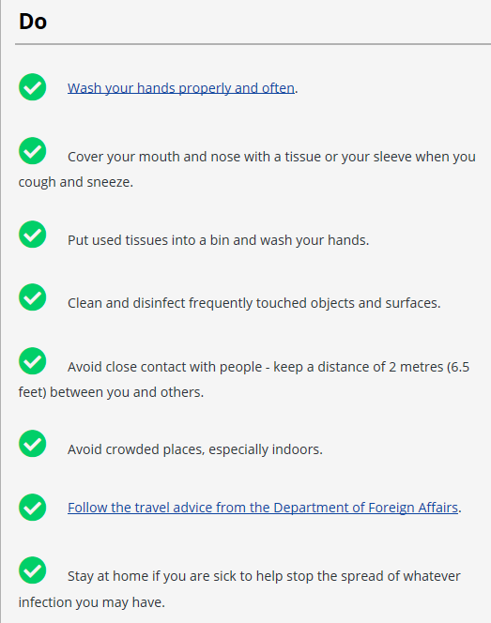
- Careful attention to hand hygiene with provision of hand sanitiser and or hand washing facilities at all entrances (where practical to provide sinks)
- Coughing / Sneezing into tissue / elbow crook
- Visitor notices advising of hand hygiene measures before, during and after visiting
- Visitor notices advising against visitors attending if they have been in contact with COVID-19 cases and if they have fever or symptoms of respiratory tract infection and until at least 48 hours after symptoms have resolved
- While the positive impact of seeing friends and family is acknowledged, this needs to be balanced against the need to keep service users safe and as such there will be the need to introduce visitor restrictions in event of COVID- 19 outbreak. A log of all visitors should be kept.
- Where possible alternative ways of engaging with friends and families e.g. Skype or Facetime should be facilitated.
- Appropriate Social Distancing measures being observed by staff and as appropriate for service users within homes/facilities where clinically appropriate
- Careful attention to handwashing with provision of handwashing and hand sanitizer at all entrances and strategic points.
- Contractors on site should be kept to a minimum
- Increase cleaning regime and ensure all hard surfaces that are frequently touched such as door handles, keyboards, telephones, hand rails, taps and toilet fittings are cleaned regularly with a household detergent.

  - If a member of staff if concerned that they may have COVID-19, they should refer to HSE guidance. Please see appendix 5 for information on risk assessment for contacts. Staff and managers should also refer to Health Surveillance website for the most current information in terms of recommendations in relation to healthcare workers including derogation for essential healthcare workers. If advised to self isolate at home, they should not visit or care for individuals until it is safe to do so. Please see appendix 2 for guidance on self-isolation for staff
  - Regular infection prevention and control training for staff with emphasis on Standard Precautions (including hand hygiene) and including the appropriate use of personal protective equipment.
  - Outings with service users/clients or any care off site should be reduced in accordance with national public health advice and policy.
  - Service users health passports should be updated in case of requirement to transfer to another setting or changes to regular staffing. See link for same https://www.hse.ie/eng/services/news/media/pressrel/launch-of-the-hse-health-passport-mission-possible-short-film.html
  - Appoint designated staff to care for COVID-19 residents for each shift. The service should maintain a log of all staff members caring for service users with COVID-19
  - Ideally care equipment should be dedicated for the use of an individual. If it must be shared, it must be cleaned and disinfected between use.
  - Prepare a service preparedness plan that reflects staff training in infection prevention & control (IPC) measures, contingency planning for outbreak management including isolation measures and cleaning procedures. This should be in line with HIQA guidance (see appendix 4) and should include;
    - Having a plan for dealing with people who become ill with symptoms including how they will be isolated from other service users & who to call for medical advice (the individuals GP or GP providing cover to the service)
    - Having a plan for how the setting will manage core services in the event of either service user or care staff becoming unwell

4. General advice regarding service users/clients suspected or infected during COVID-19 epidemic in a disability setting
- In general, residents in residential care who are COVID-19 Positive should be managed in their residential home.
- Transfer to hospital/intermediate care is only appropriate where this will confer additional benefit. Decisions to transfer should be discussed in advance with senior clinician (DON / ADON /PIC) in conjunction with GP/MO/OOH and should be made in conjunction with the person, their families (and their advanced care plans if appropriate). The decision making process and agreed outcomes should be documented and signed. Any decisions around escalation of care should be in line with HSE Operational Pathways of Care for the assessment and management of patients with COVID-19
- Ensure as far as possible that discussions with residents and families reflecting care preferences including at end of life have been identified, documented and updated as appropriate. Be aware that significant and rapid clinical change can be a feature of COVID-19 disease in some vulnerable groups and encourage timely discussions in line with same.
- Where appropriate, advance care planning should take place. These should be conducted in a safe and supportive environment by a senior clinician, and with sufficient time for the client and family members to consider the implications. The process and outcome of the Advance Care Plan should be documented.
- Decisions regarding care should be individualised to the resident.
- Seek advice from relevant acute hospital clinicians and palliative care services when appropriate. This may assist with ongoing clinical management and inform decisions re clinical appropriateness of potential decisions regarding transfer to hospital for acute management. Consideration should be made as to the appropriateness and likely outcome of full mechanical ventilation.
- Proactively manage communications with residents, staff, families and others. Refer all for guidance from www.hse.ie and www.hscp.ie

5. When a resident presents as clinically suspect for COVID-19 status procedures to be applied;
    - As per the current Health Protection Surveillance Centre (HPSC) guidance, contact should be made with the individuals GP if the individual is suspected to have Covid 19 based on having symptoms of fever (high temperature – 38 degrees Celcius of above) or chills and one of the following symptoms;
    - A cough (this can be any kind of cough, not just dry
    - Shortness of breath
    - Breathing difficulties
    - The staff member should also contact the service manager. The Disability Manager should also be informed.
    - Testing will be prioritised as follows;
    - Close contacts of a confirmed care
    - Healthcare workers
    - Those in at-risk groups
    - There may be some people for whom testing centres are not an option. This could include people with particular medical needs but also some people for whom the anxiety of using that avenue could result in behaviours of concern. In such instances, the GP should contact the National Ambulance Service to request Covid- 19 home assessment and testing. Alternatively, there may be the option of outreach from local community assessment hub once established & operational.
    - Where possible, the service user and their family should be involved in all discussions with GPs regarding referral of potential cases and appropriate discretion used in the application of clinical criteria to residents being referred for testing and recommendations should be in line with current advice from HSE/HPSC.
    - In all service settings, the service user with possible COVID 19 should be isolated while awaiting results with precautions as advised in current guidance using standard precautions. Visitors should be restricted while the individual is in isolation
    - In general, service users/clients who are COVID-19 Positive should be managed in their homes/facilities in line with recommendations.
    - Transfer to hospital/intermediate care centre is only appropriate where essential. Decisions to transfer should be discussed in advance with service user/client, their families/carers in conjunction with their GP. Any service user/client requiring hospitalisation who they believe may have COVID-19 should be flagged with the receiving hospital beforehand to discuss their individual care needs relating to their disability. The individual’s health passport should go with them.
    - Decisions regarding care should be individualised to the service user/client.
    - In the case of an outbreak of COVID-19 within a residential services, the service should be closed to all new admissions during time of the COVID outbreak
    - Proactively manage communications with service users/client, staff, families and others. Refer all for guidance from www.hse.ie and www.hscp.ie

6. Common Symptoms and Signs indicative of possible COVID-19 illness:

The main symptoms to look out for are:
- a cough - this can be any kind of cough, not just dry
- shortness of breath
- Myalgia or muscle pain
- Fatigue /tiredness
- Fever equal to or above 38^{O} /Chills

Less Common Symptoms

Anorexia | Sputum production | Sore throat
Dizziness | Headache | Rhinorrhea
Conjunctival Congestion | Chest pain | Haemoptysis
Diarrhoea | Nausea/vomitting | Abdominal Pain

Risk Factors for severe disease

Ischaemic heart disease | Chronic heart failure | Hypertension
Diabetes | Chronic Lung Disease | 1ᵒ or 2ᵒ immunosupression
Cancer | Age >60 with disability | Frailty

Red flags: Urgent medical/senior clinician review required

Fast Breathing i.e. >30 breathes/min | Difficulty Breathing | Person becomes confused or disorientated
Person feels dizzy or lightheaded/faint and/or has chest pain |  | Person hasn’t passed urine >12 hours

7. Clinical Investigations supporting diagnosis of COVID-19

Throat and nose swab for laboratory detection of virus is the method used to confirm the diagnosis. Although the test is considered generally reliable when taken in symptomatic people the test is not perfect and reliability depends on sample quality (a properly taken swab).
Contact should be made with the National Ambulance Service to request Covid- 19 home assessment and testing for individuals in residential settings.
Where there is a high clinical index of suspicion for COVID-19 (e.g. during facility outbreak), failure to detect the virus in a nose / throat swab does not entirely exclude the possibility of COVID-19.

Note also that if a resident has a clinical picture of viral respiratory tract infection, even if they do not have COVID-19 they are likely to be infected with another virus that can spread to other residents, therefore additional infection prevention and control precautions remain appropriate until the resident has recovered.

On confirmation of a diagnosis of COVID-19 further investigations may be considered appropriate to assist with management. e.g. FBC, UEC, LFTs, CXR

Investigations to out-rule underlying non-COVID-19 related conditions may be appropriate

Clinical discretion and judgement should be used regarding further investigation and in particular in identifying whether same will alter overall patient management and risks posed by transfer to and from acute hospital/intermediate care facilities for same

8. Clinical Monitoring and management of patients with suspected or confirmed COVID-19 status in a nurse-led residential service

Monitoring of vital signs by pulse oximetry, BP, RR, Temp on twice daily basis / as determined in conjunction with GP/ MO or other medical advice

Monitor for common symptoms identified above and treat accordingly with supportive measures including paracetamol and oxygen, nasal prongs where appropriate

Optimise and encourage good oral fluid and nutritional intake

Use clinical judgement regarding appropriateness of monitoring where there is an expected change in the patient’s clinical condition

Rapid and unexpected change in clinical status may occur (typically days 7-9). Ensure insofar as possible that appropriate measures to ensure comfort are made available and that staff are aware and trained in meeting resident’s needs to cater for this situation.

As appropriate, develop an anticipatory care plan with resident and / or family member using national palliative guidance and ethical framework. . Where appropriate, advance care plan should be put in place. These should be conducted in a safe and supportive environment by a senior clinician, and with sufficient time for the client and family members to consider the implications. The process and outcome of the plan should be documented.

9. Decision algorithm in regards to escalation reflecting anticipatory guidance (if appropriate)

The following anticipatory decision log below is to offer guidance to doctors and nurses who may not be familiar with the Service User as to what approach to take in the event of their acute deterioration. This document cannot cover all clinical eventualities but it may act as a guide in deciding the appropriateness of certain interventions. It is not prescriptive. The treating clinician should use their discretion to provide whatever treatment they see fit; depending on the clinical scenario is partnership with the Service User.

Intervention | Date | Date | Date | Date | Date | Date
Attempt CPR | Yes/No | Yes/No | Yes/No | Yes/No | Yes/No | Yes/No
IV/SC Fluids | Yes/No | Yes/No | Yes/No | Yes/No | Yes/No | Yes/No
Antibiotics | Yes/only if aids symptoms | Yes/only if aids symptoms | Yes/only if aids symptoms | Yes/only if aids symptoms | Yes/only if aids symptoms | Yes/only if aids symptoms
Transfer to Acute Hospital | Yes/No | Yes/No | Yes/No | Yes/No | Yes/No | Yes/No
Other

Infection Prevention and Control Measures

Note. Implementing infection prevention and control practice is extraordinarily difficult with service users who are unable to comply with requests from staff. In that setting the only practical approach is to apply the key principles of infection control as much as possible.

If an individual is unwilling/unable to comply with testing for COVID-19 and they are symptomatic, they should be managed as if they have confirmed case as described above.

A specific sub-group is being established to look at supports for those with behaviours that challenge and to make recommendations on how to ensure safety of the individual, staff and other service users

Scenario | Guidance
Management of a service user who is identified as a COVID- 19 Contact  (No symptoms) | - Such residents should be requested to avoid communal areas and wait in their room for their period of observation (until 14 days after exposure) and until Public Health advice confirms the resident can resume normal activity  - If a single room is not feasible, try to isolate in a specific area. Contact your local Community Health Social Inclusion or Public Health Link for advice. Service Users may go outside if appropriate, alone or accompanied by a staff member maintaining a distance of 1m  - Staff members who can avoid physical contact and maintain a distance of 1 m do not require apron, gloves or mask but should attend to hand hygiene  - Staff members providing direct care e.g. changing incontinence wear, assisting with toileting, providing personal hygiene, bathing/showering, transferring a person etc should wear long sleeved disposable gown, facemask, gloves as per standard precautions. Eye protection is recommended when there is a risk of blood, body fluids, excretions or secretions splashing in to the eyes. Where possible limit time (interventions of 15 mins) and distance exposure( 1m)  - Staff members should monitor at least twice per day and record if the Service User has developed symptoms of infection  - Testing should be considered in Service Users who develop sudden onset of temperature (above 38 C) without other apparent explanation, in addition to either new onset of cough, new onset of shortness of breath.

Scenario | Guidance
Management of a service user who develops fever (above 38ᵒC) or symptoms of acute respiratory tract infection | - Such residents should be requested to avoid communal areas and wait in their room until assessed. Inform families if appropriate  - Maintain a strong index of suspicion for likely Covid 19 positive disease in the service with all other residents and follow isolation protocols accordingly.  - If testing for COVID-19 is required it should be will arranged.  - Where Covid 19 Positive is not suspected to be the primary cause of symptoms, the Service User should avoid communal areas until 24 hours after resolution of respiratory symptoms or fever or until another cause of fever that does not requires specific infection prevention and control precautions is apparent  - Service Users may go outside alone if appropriate accompanied by a staff member maintaining a distance of 1m if appropriate. If coughing, the resident should wear a surgical mask. If no mask is available, they should be asked to cover mouth with tissue when coughing.  - Staff members providing direct care e.g. changing incontinence wear, assisting with toileting, providing personal hygiene, bathing/showering, transferring a person etc should wear long sleeved disposable gown, facemask, gloves as per standard precautions. Eye protection is recommended when there is a risk of blood, body fluids, excretions or secretions splashing in to the eyes. Where possible limit time (interventions of 15 mins) and distance exposure( 1m)  - Staff members providing direct care in addition to standard precautions should wear plastic apron gloves and surgical mask pending confirmation of Covid status  - Staff members who can avoid physical contact and maintain a distance of 1 m do not required apron, mask or gloves but should attend to hand hygiene  - If testing for COVID is considered necessary then proceed as below regarding suspect COVID-19 case.  - Care must be taken with utensils and clothing

Scenario | Guidance
Management when testing of a resident for COVID-19 is considered necessary (Suspect Case) | - The Service User should be considered as a suspect COVID-19 case  - The Service User should be supported to self isolate.  - Communal areas should be avoided but the service user may go outside alone or accompanied by a staff member maintaining a distance of 1m if appropriate. If coughing, the resident should wear a surgical mask. If no mask is available, they should be asked to cover mouth with tissue when coughing.  - Group activities should be suspended pending test results. If this is not possible given the overall welfare of residents activities may be conducted with small groups of residents with maintain of social distance as much as possible. (for example unaffected residents may be able to access communal areas or go outside in small groups on a rota basis with avoidance of direct contact or close contact)  - Service Users should stay in their room as much as possible and minimise contact with other residents pending test results  - Service Users should be encouraged to perform hand hygiene and respiratory hygiene and cough etiquette  - Healthcare workers should increase their attention to hand hygiene and respiratory hygiene and cough etiquette  - Visiting should be restricted to absolute necessity  - Public health should be informed and testing should be arranged according to the agreed process as quickly as possible  - Care for the Service User who is awaiting testing should be delivered by a single nominated person on each shift  - If more than one Service User requires testing consider feasibility of having one nominated person on each shift care for those residents awaiting testing  - In addition to standard precautions, the person caring for the service user should use apron, gloves and a surgical mask when within 1 m of the resident  - The Service User should be encouraged to wear a surgical mask if available or otherwise, if possible, to cover the mouth and nose with a tissue when a staff member is within 1 m  - If care of the service user requires close physical contact, in addition to standard precautions, contact & droplet precautions should be applied (staff members should wear a gown, surgical mask, eye protection and gloves)  - If the test is reported that Covid -19 is not-detected management of the resident should be as for other respiratory tract infection  - Care must be taken with utensils and clothing

Scenario | Guidance
Management if a service user tests positive for COVID-19 | - All group activities should be suspended. If this is not possible given the overall welfare of residents activities may be conducted with small groups of residents with maintain of social distance as much as possible. (for example unaffected residents may be able to access communal areas or go outside in small groups on a rota basis with avoidance of direct contact or close contact)  - The Service User should avoid communal areas until 14 days post onset of symptoms as 5 days since they had a fever (or in line with current HPSC Guidance).  - The Service User but may go outside alone if appropriate or accompanied by a staff member maintaining a distance of 1m if appropriate. The service user should wear a surgical mask. If no mask is available, they should be asked to cover mouth with tissue when coughing.  - Staff members who can avoid physical contact and maintain a distance of 1 m do not require apron, mask or gloves but should attend to hand hygiene  - Service Users should be encouraged to perform hand hygiene and respiratory hygiene and cough etiquette  - Healthcare workers should increase their attention to hand hygiene and respiratory hygiene and cough etiquette  - Visiting should be restricted to absolute necessity  - Care for the Service User who has tested positive should be delivered by a single nominated person on each shift if self care not feasible  - If more than one Service User has tested positive consider feasibility of having one nominated person on each shift care for those Service User s who have tested positive and any patients awaiting testing  - In addition to standard precautions, staff who are providing direct care need to implement contact and droplet precautions ( apron, gloves and a surgical mask see appendix 3 for PPE information) when within 1 m of the Service User for a brief period to perform a simple task  - The Service User should be encouraged to wear a surgical mask if available or otherwise, if possible, to cover the mouth and nose with a tissue when a staff member is within 1m care of the Service User requires close physical contact, in addition to standard precautions, staff members should wear a gown, surgical mask, eye protection and gloves  - Care must be taken with utensils and clothing

Scenario | Guidance
Management if more than one service user in a facility tests positive for COVID-19 i.e. potential COVID- 19 outbreak | - Public Health should be informed as soon as possible of all suspected and confirmed outbreaks of COVID-19. (This is a legal obligation)  - Disability Operations will also require notification  - A decision to convene an outbreak control team will be agreed between the Disability services and Public Health.  - Daily Outbreak Control Team OCT meetings are likely (at least initially) to report on outbreak control measures and updates on potential and confirmed new cases  - Outbreak control measures should be implemented as soon as possible  - Disability facility staff must ensure that Standard Precautions are reinforced and Transmission Based Precautions, including Droplet and Contact Precautions are implemented immediately, if not already in place  - Identify appropriate area for isolating and cohorting of isolated cases where possible  - Local hospitals and National Ambulance Service notified (in event of anticipated patient transfer) by senior clinician.  - Identified outbreaks should be notified to GP OOH services  - GP/NCHD and Area DON to liaise with local treating acute hospital physicians where appropriate in decisions re transfers  - Monitor clinical condition for change and follow national guidance on criteria for hospital/intermediate care centre admission where this is the ongoing treatment plan  - Care planning should reinforce all infection prevention and control measures to cover eventuality of hospital / other facility transfer  - Consider cancelling non-essential outward movement of Service Users  - Close the facility to new Service User s and transfers if possible  - Close the facility to all non-essential visitors

Scenario | Guidance
Management of transfer of service user to hospital /intermediate care centre for treatment of COVID-19 | - A person who is COVID-19 positive with severe symptoms should be transferred to an acute hospital/intermediate care centre for management of their symptoms on the advice of their GP/GP assigned to the service. Consideration should be made as to the appropriateness and likely outcome of full mechanical ventilation.  - Depending on the severity/acuity of their presentation an ambulance should be called.  - Acute hospital/intermediate care centre should be notified about the planned transfer and given summary information on the individual’s current status as well as care needs.  - If the individual is being transferred to an acute hospital/intermediate care centre and has an advance care plan, this should be communicated to the hospital in advance of transfer.  - Family should be notified immediately  - Where feasible, a staff member can transfer with the service user to the hospital, however where this is not possible, a hospital ‘passport’ which describes the individuals needs in terms of cognition/communication etc should travel with them. (Link for information on same https://www.hse.ie/eng/services/news/media/pressrel/launch-of-the-hse-health-passport-mission-possible-short-film.html  - Individual should be asked to wear surgical mask  - When transferring a person and unable to maintain 1m distance and likely to have direct contact, the healthcare worker should use PPE as described previously. If able to maintain physical distance, the health care worker should maintain hand hygiene but no PPE required.  - Once an individual with COVID-19 leaves the facility the room where they were isolated the room should not be cleaned or used for one hour and during this time the door to the room should remain closed.  - Ensure all surfaces that the service user came in contact with are cleaned.  - The person assigned to clean the room should wear gloves (if available), either disposable latex free gloves or household gloves, then physically clean the environment and furniture using a household detergent solution followed by a disinfectant or combined household detergent and disinfectant for example one that contains a hypochlorite (bleach solution). Products with these specifications are available in different formats including wipes.  - No special cleaning of walls or floors is required.  - Cleaning of communal areas If a service user spent time in a communal such as dining room, reception area, play area, or used the toilet or bathroom facilities, then these areas should be cleaned with household detergent followed by a disinfectant (as outlined above) as soon as is practicably possible.

Scenario | Guidance
Management of service user being repatriated from acute hospital /intermediate care centre post COVID-19 | If admission to acute hospital/intermediate care centre for symptom management is indicated, the individual service user should be supported to returning to their residence as soon as they are medically stable and can have their care needs managed outside of the hospital setting.  Ideally they should be COVID-19 negative, however if they are still positive they should be managed as outlined in the guidance above

Scenario | Guidance
Death in the residential setting  When a resident dies (COVID-19 positive)  Coroner  Refer to statement from the Coroners Society of Ireland version1. Dated 11/03/2020 http://www.coroners.ie/en/COR/Coroners%20Service%20COVID-19%20110320.pdf/Files/Coroners%20Service%20COVID-19%20110320.pdf  Communication of level or risk | Use the HSE guidance documents on Verification and Pronouncement and Death. Please refer to your local service policies on Regulation 19 General Health And Regulation 14 Care Of The Dying  As COVID-19 is a new and emerging pathogen it is understandable that those who will be handling the remains will be concerned and should be made aware of the patient’s infectious status.  Embalming  - Embalming is not recommended.  Hygienic preparation  - Any infection control procedures that have been advised before death must be continued in handling the deceased person after death  - Hygienic preparation includes washing of the face and hands, closing the mouth and eyes, tidying the hair and in some cases shaving the face.  - Washing or preparing the body is acceptable if those carrying out the task wear long-sleeved gowns gloves , a surgical mask and eye protection if there is a risk of splashing) which should then be discarded.  Transporting the deceased person  - Bodies should be placed in a body bag prior to transportation to the mortuary as this facilitates lifting and further reduces the risk of infection.  - A face mask or similar should be placed over the mouth of the deceased before lifting the remains into the body bag.  - Those physically handling the body and placing the body into the bag should wear, at a minimum, the following PPE:  - Gloves  - Long sleeved gown  - Surgical facemask  - Play close attention to washing hands after removal of PPE  Once in the hospital mortuary, it would be acceptable to open the body bag for family viewing only. The family should be advised not to kiss the deceased and should clean their hands with alcohol hand rub or soap and water after touching the deceased. PPE is not required for transfer once the body has been placed in the coffin  See guidance document for funeral directors  https://www.hpsc.ie/a-z/respiratory/coronavirus/novelcoronavirus/guidance/funeraldirectorsguidance/Guidance%20Funeral%20Directors%20v1.3.pdf

Appendix 1 – easy read information on standard precautions and symptoms
How can I protect myself?
Wash your hands with soap and warm water | 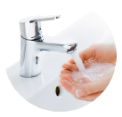
Dont touch your face with your hands
When you cough and sneeze, cover your mouth and nose with your bent elbow or a tissue
Put used tissues into a closed bin and wash your hands
Make sure to keep surfaces clean, especially surfaces people touch a lot
Don’t shake hands
Keep your distance and reduce the amount of time you are close to other people. Don’t go to crowded places

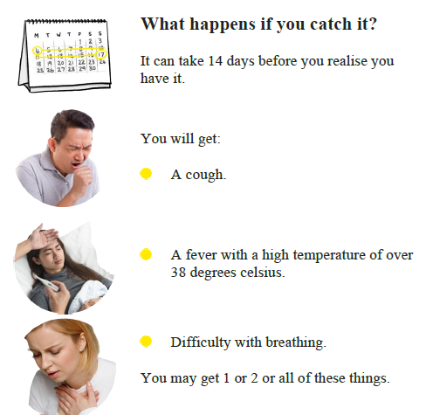

Appendix 2 – Self Isolation Guidance for Staff (HPSC)
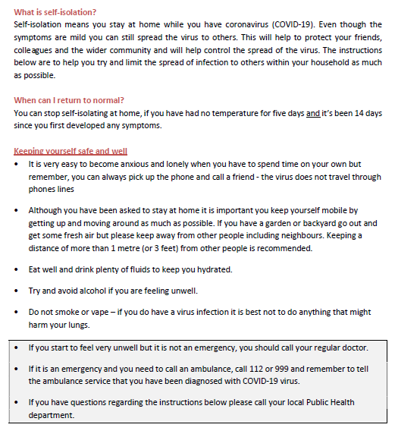

Appendix 3
PPE information
Types of PPE
- Disposable plastic aprons: are recommended to protect staff uniform and clothes from contamination when providing direct patient care and when carrying out environmental and equipment decontamination.
- Fluid resistant gowns: are recommended when there is a risk of extensive splashing of blood and or other body fluids and a disposable plastic apron does not provide adequate cover to protect HCWs uniform or clothing.
- If non- fluid resistant gowns are used and there is a risk of splashing with blood or other body fluids a disposable plastic apron should be worn underneath.
- Eye protection/Face visor: should be worn when there is a risk of contamination to the eyes from splashing of blood, body fluids, excretions or secretions (including respiratory secretions)
  - Surgical mask with integrated visor
  - Full face shield or visor
  - Goggles / safety spectacles
- Surgical Face Masks
  - Surgical Face Masks (Fluid Resistant Type 11R)

- Tips when wearing a surgical face mask
  - Must cover the nose and mouth of the wearer
  - Must not be allowed to dangle around the HCWs neck after or between each use
  - Must not be touched once in place
  - Must be changed when wet or torn
  - Must be worn once and then discarded as health care risk waste (as referred to as clinical waste)

Appendix 4 – HIQA
COVID-19 Contingency Planning in Designated Centres
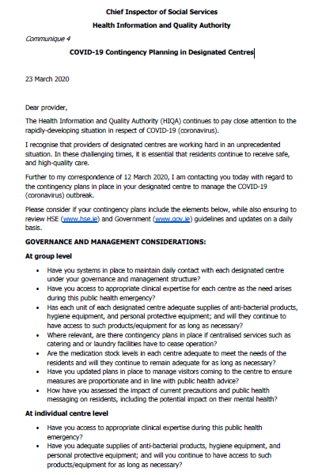
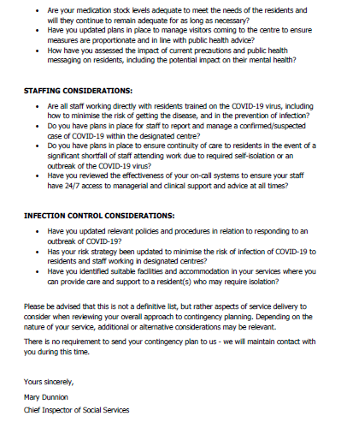

Appendix 5 – HSPC Guidance on risk assessment for COVID contacts
